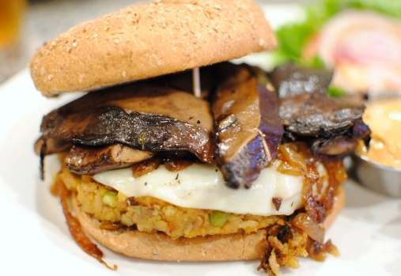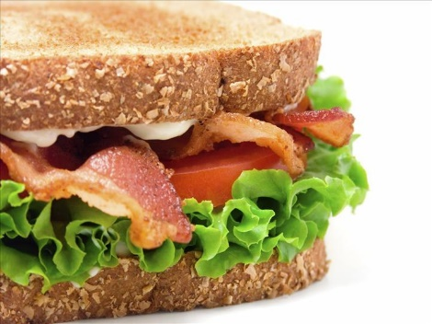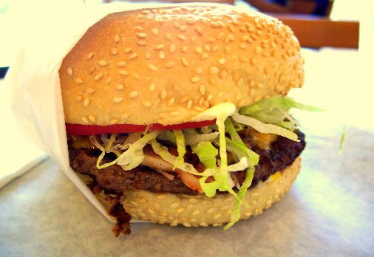
Hot Food Selection

Hot Breakfast Rolls  Sausage  Sausage and Beans  Sausage and Cheese  Sausage and Onion  Sausage and Egg  Sausage and Bacon  Bacon  Bacon and Beans  Bacon and Cheese  Bacon and Mushroom  Bacon and Egg  Bacon, Egg and Sausage  Bacon, Cheese and Beans  Sausage, Cheese and Beans  Bacon, Sausage and Mushroom  Bacon, Sausage and Cheese | £3.20  £3.70  £3.70  £3.70  £3.70  £4.40  £3.70  £3.70  £3.70  £3.70  £3.70  £4.80  £4.20  £4.20  £4.60  £4.60 | Burgers  Cheese Burger  Cheese Burger and Onion  Cheese Burger and Bacon  Spicy Chicken Fillet and Cheese  Spicy Chicken Fillet and Bacon  Hot Pastries  Sausage Roll  Cornish Pasty  Breakfast Branchy  Ham and Cheese Slice  Kebab roll | £3.80  £4.10  £4.60  £3.90  £4.80  £1.60  £2.50  £2.50  £2.50  £4.20

